Variable Name | Variable Description |  | Variable Codes
dbGaP SUBMITTER SUBJECT ID (ID2)¹ | dbGaP Submitter Subject ID for AREDS2 |  | NA
CORIELL SAMPLE ID | DNA sample number |  | NA
CONSENT STATUS | Consent type |  | GRU=General Research Use, EDO=Eye Disease Research Only
CONTROL | Is from a Control Subject |  | Yes=Control Subject, No=AREDS2 Subject
AGE | Age in years at randomization (AREDS2 subjects) or at blood draw (Control subjects) |  | NA
GENDER | Gender |  | Male, Female
RACE | Race |  | White, Black, Asian, American Indian, Alaskan Native, Native Hawaiian or Other Pacific Islander, Other
ETHNICITY | Ethnicity |  | Not Hispanic Origin, Hispanic Origin
RE  BASELINE  AMD  SEVERITY  SCALE | Severity Scale in right eye at baseline visit [See below for additional information about Neovascular AMD type and Severity Scale Steps 1 through 9.] | 1=AMD Severity Scale Step 1, 2=AMD Severity Scale Step 2, 3=AMD Severity Scale Step 3, 4=AMD Severity Scale Step 4, 5=AMD Severity Scale Step 5, 6=AMD Severity Scale Step 6, 7=AMD Severity Scale Step 7, 8=AMD Severity Scale Step 8, 9=Any Geographic Atrophy, 10=Central Geographic Atrophy (GA), 11a/11b=Neovascular AMD²
RE  FINAL  POST-BASELINE  AMD  SEVERITY  SCALE | Severity Scale in right eye at final post-baseline graded visit  [See below for additional information about Neovascular AMD Type and Severity Scale Steps 1 through 9.] |  | None=No Post-baseline Visit, 1=AMD Severity Scale Step 1, 2=AMD Severity Scale Step 2, 3=AMD Severity Scale Step 3, 4=AMD Severity Scale Step 4, 5=AMD Severity Scale Step 5, 6=AMD Severity Scale Step 6, 7=AMD Severity Scale Step 7, 8=AMD Severity Scale Step 8, 9=Any Geographic Atrophy, 10=Central Geographic Atrophy (GA), 11a/11b=Neovascular AMD²
RE FINAL POST-BASELINE GRADED VISIT | Final post-baseline graded visit in right eye |  | None, Year 1, Year 2, Year 3, Year 4, Year 4, Year 6
LE  BASELINE  AMD  SEVERITY  SCALE | Severity Scale in left eye at baseline visit [See below for additional information about Neovascular AMD Type and Severity Scale Steps 1 through 9.] |  | 1=AMD Severity Scale Step 1, 2=AMD Severity Scale Step 2, 3=AMD Severity Scale Step 3, 4=AMD Severity Scale Step 4, 5=AMD Severity Scale Step 5, 6=AMD Severity Scale Step 6, 7=AMD Severity Scale Step 7, 8=AMD Severity Scale Step 8, 9=Any Geographic Atrophy, 10=Central Geographic Atrophy (GA), 11a/11b=Neovascular AMD²
LE  FINAL  POST-BASELINE  AMD  SEVERITY  SCALE | Severity Scale in left eye at final post-baseline graded visit  [See below for additional information about Neovascular AMD Type and Severity Scale Steps 1 through 9.] |  | None=No Post-baseline Visit, 1=AMD Severity Scale Step 1, 2=AMD Severity Scale Step 2, 3=AMD Severity Scale Step 3, 4=AMD Severity Scale Step 4, 5=AMD Severity Scale Step 5, 6=AMD Severity Scale Step 6, 7=AMD Severity Scale Step 7, 8=AMD Severity Scale Step 8, 9=Any Geographic Atrophy, 10=Central Geographic Atrophy (GA), 11a/11b=Neovascular AMD²
LE FINAL POST-BASELINE GRADED VISIT | Final post-baseline graded visit in left eye |  | None, Year 1, Year 2, Year 3, Year 4, Year 4, Year 6

¹Note: This participant ID was created for putting the clinical data into a publicly available database such as the dbGaP, once that occurs, and is different than the participant ID used by the clinical sites.
²11a= Neovascular AMD with definite presence of one of the following five characteristics of neovascular AMD: SSR detachment, PED, subretinal/sub-RPE hemorrhage, hard exudate, or fibrous tissue
11b= Neovascular AMD with end-stage disease (e.g., definite disciform scar, or photocoagulation scar), or two or more of the following five characteristics of neovascular AMD: SSR detachment, PED, subretinal/sub-RPE hemorrhage, hard exudate, or fibrous tissue

Note that for Neovascular (NV) AMD, 11a is the definition for AREDS and 11b is the definition from AREDS2 which was much stricter.

If an eye met the criteria for 11a but not 11b, the Reading Center would indicate them as being 11a but then also coded them using the other non-advanced AMD Severity Scale steps (which are 1 through 9, advanced AMD is 10, 11a, or 11b) since they were not counted as NV AMD with the new AREDS2 definition.

AMD Severity Scale 1 through 9:
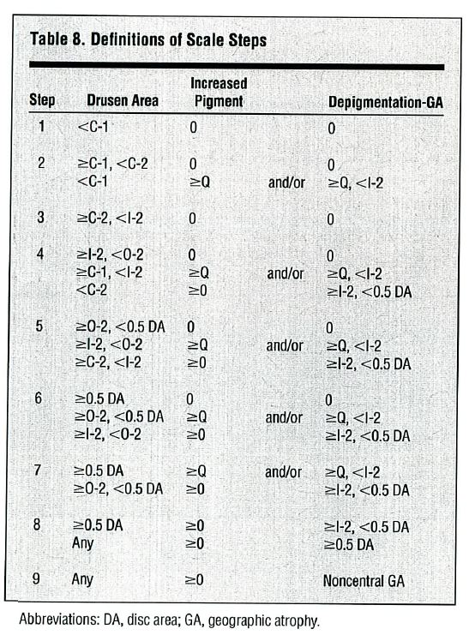
AMD Severity Scale Steps 1 through 9 are summarized in Table 8 from AREDS Report 17 (right). Note that Steps 1 through 8 do not have any geographic atrophy (GA) and step 9 has only non-central GA. Also note that ‘Q’ means ‘questionable’ and that C-1, C-2, I-2, O-2 are standard circles used in grading that are described in more detail in Figure 1 from AREDS Report 17 (see below).
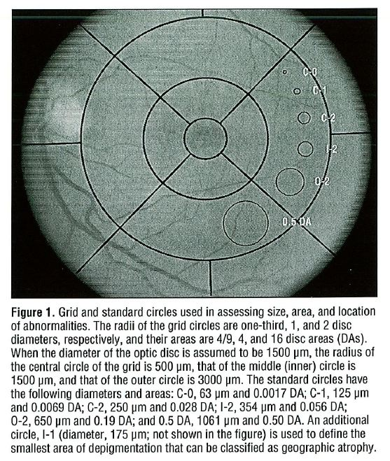
The original publication on AMD Severity Scale from AREDS is published here:
Davis MD, Gangnon RE, Lee LY, Hubbard LD, Klein BE, Klein R, Ferris FL, Bressler SB, Milton RC, Age-Related Eye Disease Study Group, “The Age-Related Eye Disease Study severity scale for age-related macular degeneration: AREDS Report No. 17.” Arch Ophthalmol. 2005 Nov; 123(11):1484-98.
The follow-up publication on AMD Severity Scale for AREDS2 is published here:
Vitale S, Clemons TE, Agrón E, Ferris III FL, Domalpally A, Danis RP, Chew EY, Age-Related Eye Disease Study 2 (AREDS2) Research Group, “Evaluating the Validity of the Age-Related Eye Disease Study Grading Scale for Age-Related Macular Degeneration: AREDS2 Report 10.” JAMA Ophthalmol. 2016 Sep 1;134(9):1041-7.

